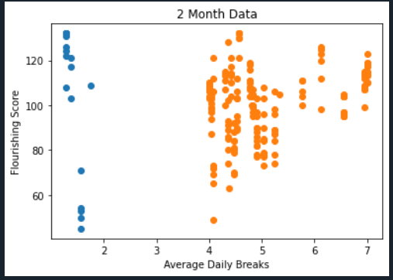

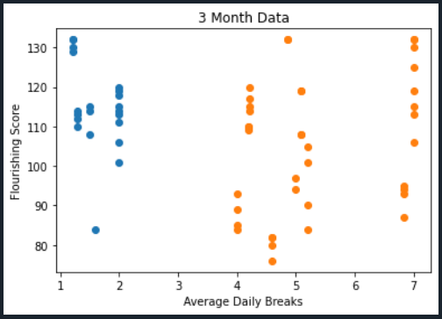

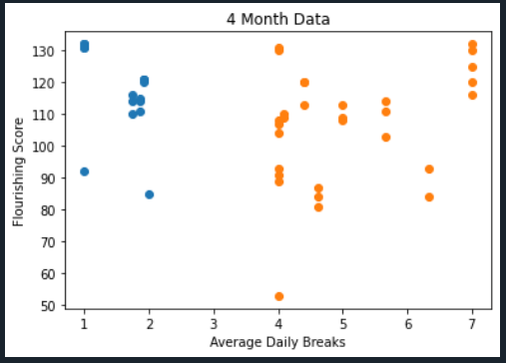

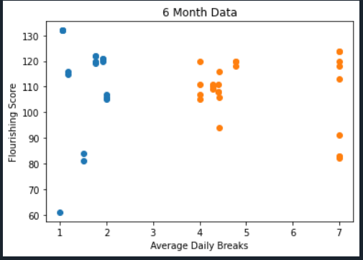

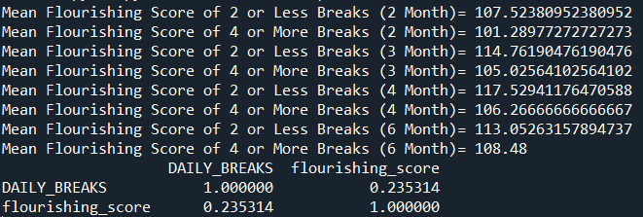

Documentation:

To run the code, first download the csv files Daily END6.csv and Friday AM6.csv. Then also download ModifiedPlotsandAverages.py. Then place them in the same folder as ModifiedPlotsandAverages.py. Then simply run the python code. Running the code will require matplotlib and pandas. This will produce the above plots and the averages of the flourishing scores. It will also produce the p-value of the correlation between average daily breaks and flourishing score (for break values of <=2 and >=4).